The Fourteenth Sunday after Pentecost
August 25, 2013

Holy Baptism Page 299
Organ Prelude
Entrance Hymn, Hymnal #8 Morning Has Broken

Celebrant: Blessed be God: Father, Son, and Holy Spirit
Congregation: And blessed be his kingdom, now and forever. Amen.

Celebrant: There is one Body and one Spirit;
Congregation: There is one hope in God’s call to us;

Celebrant: One Lord, one Faith, one Baptism;
Congregation: One God and Father of all.

Celebrant: The Lord be with you.
Congregation: And also with you.

The Collect of the day

THE LESSONS

Old Testament Reading bulletin insert

The Psalm bulletin insert

New Testament Reading bulletin insert

Celtic Alleluia (Sung before and after the Gospel is read)

Gospel (All stand) bulletin insert

Sermon The Rev. Mary Trainor

Baptismal Hymn, Hymn #490 I Want to Walk as a Child of the Light

Presentation and Examination of the Candidate Page 301

The Baptismal Covenant Page 304

Prayers for the Candidates Page 305

Thanksgiving over the water Page 306

The Baptism Page 307

The Peace Page 308

Offertory Hymn #699 Jesus, lover of my soul

"Praise God from whom all blessings flow" Hymnal #380, v3

The Great Thanksgiving

Eucharistic Prayer B Page 367

Sanctus -“Holy, Holy, Holy” Hymnal # S130

All baptized Christians are welcome to receive Holy Communion

Post Communion Hymn #304 I come with joy to meet my Lord

Concluding Prayer Page 366

Blessing

Recessional Hymn #411 O bless the Lord, my soul

Dismissal, Announcements and Postlude

++++++++++++++++++++++++++++++++++++++++

Welcome, visitors! Please see the pews for a special welcome card and information about St. John's Episcopal Church.

Today at St. John’s
Come to coffee hour and enjoy the fellowship!

Announcements
This is the week for the Shawano Community Meal, Presbyterian Church, 5:30. You can just show up -- it is free! See Nancy Clasen for more information to help out.

Help those who are needy in our community. Please bring non-perishable (canned or dried goods) foods to church and place them in the basket near the Church entrance; food is delivered weekly to the Shawano Food Pantry (check dates on food please). You can also bring cleaning supplies and toiletry items for those staying at the Shawano Domestic Abuse Shelter; please place these items in marked bins in the hallway from the church to the parish hall.

St. John's Upcoming Events:

September 1: 11:00 AM Bishop's Committee Meeting
September 8: 9:30 AM Outdoor mass, parish picnic and pony rides for children
September 8: 1:30 PM: Blessing of the Animals
October 20: Potluck after mass, Consecration Sunday

PICK UP IN THE RACK IN THE HALL:
- flyers that tell you about St. John's
- copies of today's sermon
- copy of the Church and Diocese electronic newsletter
- tracts that help with life's issues

Diocesan Calendar
10/3: Meet Bishop candidates" at St. John's in Wausau this evening!
10/18-19: Diocesan Convention, Fond du Lac (elect new bishop)
4/26/14: Consecration of the new Bishop of Fond du Lac



St John’s staff:
Vicar- The Rev. Mary S. Trainor; Organist – Ted Myers
Bishop’s Committee: Senior Warden - Ron Stezenski; Jr. Warden- Art Frieberg; Marlene Brown, Nancy Clasen, Joe Keberlein, Wendy Hafner, LouAnne Zander; Treasurer - Sue Sazama; Clerk – Lois Renner; Youth Liaison, Ted Myers.

14th Sunday after Pentecost

August 25, 2013
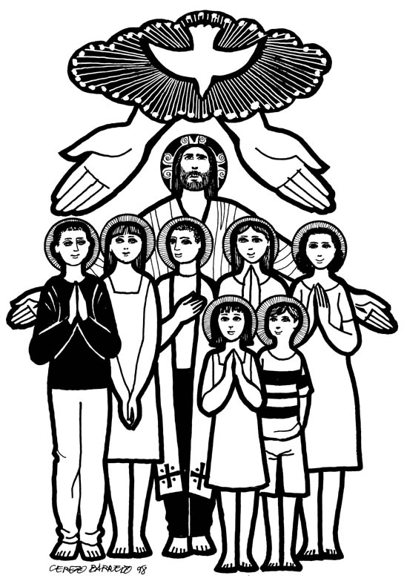

St. John’s Episcopal Church

141 South Smalley St., Shawano, WI

http://www.shawanoepiscopal.org

The Rt. Rev. Russell Jacobus, Bishop

The Rev. Mary S. Trainor, Vicar

Church Phone 715-526-3686

Vicar’s Phone 715-252-4816

pastormaryt@gmail.com

